

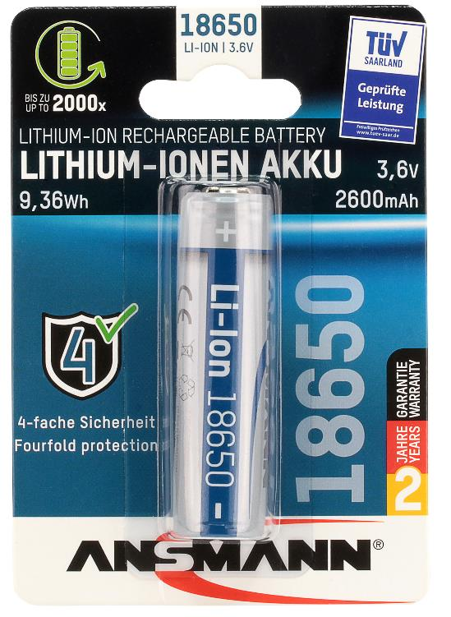

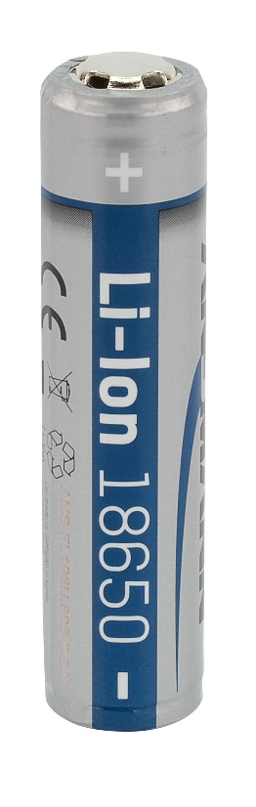

ANSMANN 18650 – 3.6V 2600mAh (9.36Wh)
- High quality ANSMANN Lithium battery 18650 with safety board
- Ideal for use in modern devices like LED torches, headlights, e-cigarettes, laser pens, etc.
- Integrated protection circuit against overload, short circuit and deep discharge
- Max. long charging current: 5.2A
- Very low self-discharge and high energy efficiency
- Very good price/performance ratio
- 2 years warranty

INFORMATION

Product name: Li-Ion 18650 3.6V 2600mAh
Article number: 1307-0000
EAN-Code: 4013674092437
Product: 18x65mm / 40g
Packing + Product: 86x23x123mm / 47g
Packing unit: 10 (237x92x102mm)

Customs tariff number: 85076000
MRSP: 14,99 €
Material group: 04


