

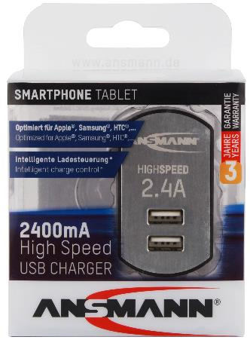
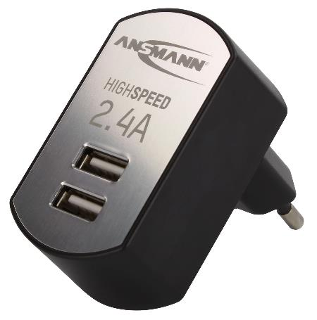

ANSMANN High Speed USB charger 2.4A
- Intelligent universal charger with two USB ports
- Protects your end device as well as the charger itself from overloads and short-circuits
- Automatic monitoring of the output voltage and output current
- With intelligent charging control, which automatically detects and uses the highest possible charge current for your end devices
- Suitable for devices that can be charged via USB
- Compatible with Samsung, Apple, Nokia, HTC, MP3 players, navigation devices and other smartphones and mobile phones
- Compact and space-saving construction – very good haptics
- Input: 100-240V (can be used worldwide)
- Output: 5V max. 2400mA
- 3 year ANSMANN-Germany manufacturer's guarantee

INFORMATION

Product name: iUSBCHARGER 2.4 DUO
Article number: 1001-0031
EAN code: 4013674067114
Product: 60x34x61mm / 58g

Packaging + product: 86x68x123mm / 104g
Packaging unit: 16 (380x45x180mm)
Delivery: CW 08/2016
Customs tariff number: 85044055
RRP: 17.99 €
Material group: 01

